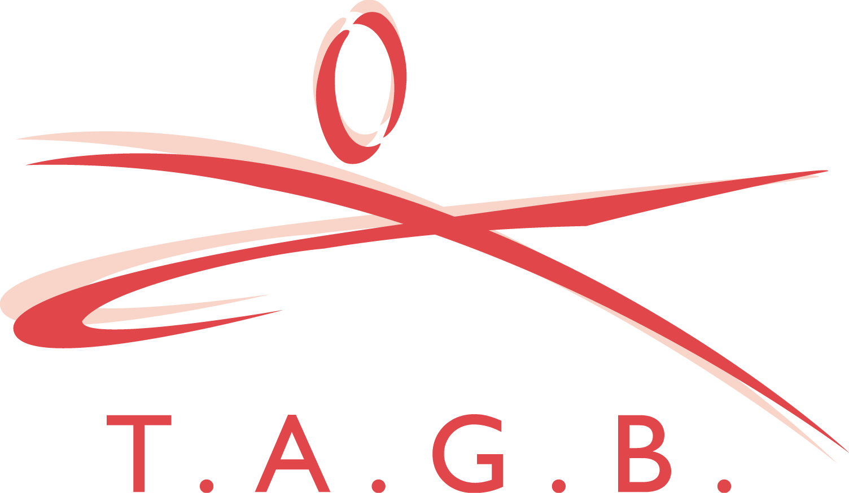
T.A.G.B SOUTH EAST CHAMPIONSHIPS
K2 Crawley
Pease Pottage Hill
Crawley
West Sussex.
RH11 9BQ

Sunday 31st October 2010.

Dear Instructor

You and your students are invited to attend the above event.

All competitors to arrive by 9.30 a.m.

The following divisions will apply.

** Please note: There are NO divisions for cadets or executives at this event.

Juniors: Up to and including 15 years old.

Adults: 16 years old and above

Closing date for entries will be: Sunday 17th October 2010.

Payment: Cheques made out to BL TAE KWON-DO SCHOOLS.

Entry fee’s: Competitor: £10 per event (i.e. 3 events = £30).
Spectators: £7.00

TAG team: £15 per 3-person team. To be paid and entered on the day.

Officials: Officials must register before the event. Stating their qualification.
Officials Uniform: Officials t-shirt, grey or black pants and sports shoes.
** You must arrive by 9 a.m. otherwise you will be asked to pay to enter. Bring your black belt licence book for stamping to record your attendance.

NO VIDEO CAMERAS PERMITTED ON THE AREA’S.
NO SPECTATORS ALLOWED ON THE AREAS.

PATTERN DIVISIONS:
Juniors: (boys and girls separate) Adults: (male and female separate)
Yellow: 9th Kup to 7th Kup Yellow: 9th Kup to 7th Kup
Green: 6th Kup to 5th Kup Green: 6th Kup to 5th Kup
Blue: 4th Kup to 3rd Kup Blue: 4th Kup to 3rd Kup
Red: 2nd Kup to 1st Kup Red: 2nd Kup to 1st Kup
Black: All grades together Black: All grades together.

BLACK | BLACK | RED | BLUE | GREEN | YELLOW
Sam-Il | Choong Moo | Toi Gye | Yul Gok | Do San | Chon Ji
Yoo Sin | Kwang Gae | Hwa Rang | Joong Gun | Won Hyo | Dan Gun
Choi Young | Gae Baek | Choong  Moo | Toi Gye | Yul Gok | Do-San
Tong-Il | Po-Eun
Ul-Ji | Ko-Dang
Se-Jong | Choi Jang
Yon-Ge | Eui-Am
Moon-Moo

So San

SPARRING DIVISIONS
JUNIOR: Boys and Girls separate.
BLACK  Continuous | RED  Point stop | BLUE  Point stop | GREEN  Point stop | YELLOW  Point stop
PEE WEE  Over 122cm up to & inc 137cm | PEE WEE  Over 122cm up to & inc 137cm | PEE WEE  Over 122cm up to & inc 137cm | PEE WEE  Over 122cm up to & inc 137cm | PEE WEE  Over 122cm up to & inc 137cm
LIGHTWEIGHT  Over 137cm up to & inc 152cm | LIGHTWEIGHT  Over 137cm up to & inc 152cm | LIGHTWEIGHT  Over 137 cm up to & inc 152cm | LIGHTWEIGHT  Over 137 cm up to & inc 152cm | LIGHTWEIGHT  Over 137 cm up to & inc 152cm
MIDDLEWEIGHT  Over 152cm up to & inc 168cm | MIDDLEWEIGHT  Over 152cm up to & inc 168cm | MIDDLEWEIGHT  Over 152cm up to & inc 168cm | MIDDLEWEIGHT  Over 152cm up to & inc 168cm | MIDDLEWEIGHT  Over 152cm up to & inc 168cm
HEAVYWEIGHT  Over 168cm | HEAVYWEIGHT  Over 168cm | HEAVYWEIGHT  Over 168cm | HEAVYWEIGHT  Over 168cm | HEAVYWEIGHT  Over 168cm

ADULT FEMALE SPARRING DIVISIONS:
BLACK  Continuous | RED  Continuous | BLUE  Continuous | GREEN  Point stop | YELLOW  Point stop
LIGHTWEIGHT  Up to & inc 55kg | LIGHTWEIGHT  Up to and inc 55kg | LIGHTWEIGHT  Up to & inc 55kg | LIGHTWEIGHT  Up to & inc 55kg | LIGHTWEIGHT  Up to & inc 55kg
MIDDLEWEIGHT  Over 55kg up to & inc 61kg | MIDDLEWEIGHT  Over 55kg up to & inc 61kg | MIDDLEWEIGHT  Over 55kg up to & inc 61kg | MIDDLEWEIGHT  Over 55kg up to & inc 61kg | MIDDLEWEIGHT  Over 55kg up to & inc 61kg
LIGHT HEAVY  Over 61kg up to & inc 67kg | LIGHT HEAVY  Over 61kg up to & inc 67kg | LIGHT HEAVY  Over 61kg up to & inc 67kg | LIGHT HEAVY  Over 61kg up to & inc 67kg | LIGHT HEAVY  Over 61kg up to & inc 67kg
HEAVYWEIGHT  Over 67kg | Heavy  Over 67kg | Heavy  Over 67kg | Heavy  Over 67kg | Heavy  Over 67kg

ADULT MALE SPARRING DIVISIONS:
BLACK  Continuous | RED  Continuous | BLUE  Continuous | GREEN  Point stop | YELLOW  Point stop

FLYWEIGHT
Up to & inc 58kg
LIGHTWEIGHT  Over 58kg up to & inc 64kg | LIGHTWEIGHT  Up to & inc 64kg | LIGHTWEIGHT  Up to & inc 64kg | LIGHTWEIGHT  Up to & inc 64kg | LIGHTWEIGHT  Up to & inc 64kg
WELTERWEIGHT  Over 64kg up to & inc 70kg | WELTERWEIGHT  Over 64kg up to & inc 72kg | WELTERWEIGHT  Over 64kg up to & inc 72kg | WELTERWEIGHT  Over 64kg up to & inc 72kg | WELTERWEIGHT  Over 64kg up to & inc 72kg
MIDDLEWEIGHT  Over 70kg up to & inc 76kg | MIDDLEWEIGHT  Over 72kg up to & inc 80kg | MIDDLEWEIGHT  Over 72kg up to & inc 80kg | MIDDLEWEIGHT  Over 72kg up to & inc 80kg | MIDDLEWEIGHT  Over 72kg up to & inc 80kg
LIGHT HEAVY
Over 76kg up to & inc 82kg

HEAVYWEIGHT  Over 82kg | HEAVYWEIGHT  Over 80kg | HEAVYWEIGHT  Over 80kg | HEAVYWEIGHT  Over 80kg | HEAVYWEIGHT  Over 80kg

DESTRUCTION (BLACK BELT ADULTS ONLY)

MALE HAND | MALE FOOT | FEMALE HAND | FEMALE FOOT.
Fore fist Punch | Jumping Turning Kick | Any hand technique | Any foot technique

RULES OF THE TAG TEAM SPARRING.

ALL TEAM EVENTS TO START AFTER THE INDIVIDUAL EVENTS.

Teams will consist of a 3 person team: bouts will be for 4 minutes. Each time the bout is stopped you can change with a member of your team by tagging your team members glove. All 3 members must fight at some stage during the bout. All team matches will be point stop.

TAG TEAM SPARRING DIVISIONS

MALE:
3 person team. Yellow/Green belts together. No weights
3 person team. Blue/red belts together. No weights
3 person team. Black belts. No weights

FEMALE:
3 person team. Yellow/green belts together. No weights
3 person team. Blue/red belts together. No weights
3 person team. Black belts. No weights

JUNIOR’S. (boys and girls separate)
3 person team. Yellow/Green belts together. Must all be same height
3 person team: Blue/Red belts together. Must all be same height
3 person team: Black belts. Must all be same height.
*There will be four junior divisions:
- Pee wee
- Lightweight
- Middleweight
- Heavyweight.

All junior teams are under 15 years old and all senior teams are 16 and over.

