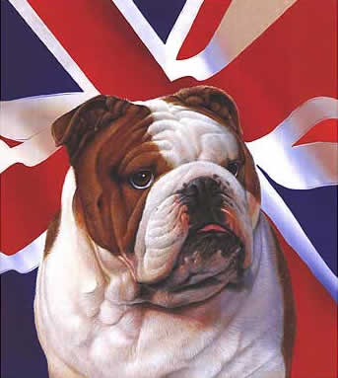
THE T.A.G.B.
BRITISH CHAMPIONSHIPS

SUNDAY 22ND NOVEMBER 2009.

University of Wales Institute. Cyncoed Road,
Cardiff. CF23 6XD

Dear Instructor
You and your students are invited to attend the above event.

ARRIVAL TIMES:
All competitors to arrive at 9.30 a.m.

CLOSING DATE FOR ENTRIES:
The closing date for entries and officials will be: Thursday 5th November 2009. All entries received after this date WILL BE RETURNED. No faxed entries, no special deliveries.

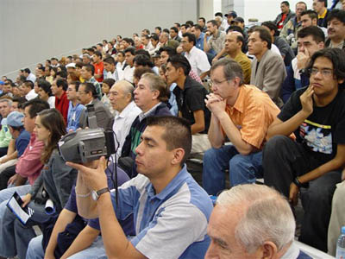
SPECTATORS.

Spectators ARE NOT ALLOWED on the competition areas. Failure to adhere to these rules will result in them being asked to leave the tournament.

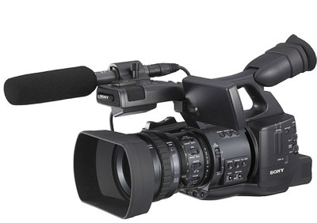
NO VIDEO CAMERA’S PERMITTED.

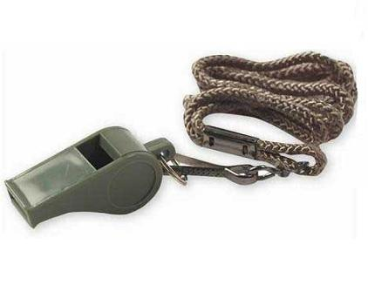
OFFICIALS:

Officials must wear the official t-shirt with grey or black pants and sports shoes. NOT SHIRT & TIE. These can be obtained from Mr. Donnelly. All officials to take their black belt licence book for recording their attendance.

SPARRING
Yellow Stripe (9th Kup) are now allowed in competitions. They are in with Yellow Belt (8th Kup) and Green Stripe (7th Kup). They are all in one division coded “YE” on the Entry Form.

JUNIORS CADET MALE

Upto & incl. 14 yrs 15 yrs & up to & including 17 yrs
ALL POINT STOP ALL BELT COLOURS SEPERATE Yellow/Greens together Point Stop.
Blue/Red together & Black belts separate. Continuous
` Sparring.
Tiny Tots | Upto & incl. 4ft (yellow & green only
Pee Wee | Upto & incl 4’6”
Lightweight | Upto & incl 5’
Middleweight | Upto & incl 5’6”
Heavyweight | Over 5’6”
Lightweight | Upto & incl. 55kg
Middleweight | Upto & incl 65kg
Light Heavyweight | Upto & incl 75kg
Heavyweight | Over 75kg

CADET FEMALE COLOURED BELT MEN
15 yrs & upto & incl. 17 yrs Yellow/Green point stop. Blue/Red continuous
Yellow/Green belts together Point Stop All belt colours separate divisions
Blue/Red together & Black separate. Continuous sparring.
Lightweight | Upto & incl 50kg
Middleweight | Upto & incl. 55kg
Heavyweight | Over 55kg
Yellow/Green together | Blue/Red together
Black belts separate
Lightweight | Upto & incl 64kg
Welterweight | Over 64kg upto & incl 72kg
Middleweight | Over 72kg upto & inc 80kg
Heavyweight | Over 80kg

COLOURED BELT LADIES BLACK BELT MEN
Lightweight | Upto & incl 56kg
Middleweight | Over 56kg upto & incl 60kg
Heavyweight | Over 60kg
Flyweight | Upto & incl. 58kg
Lightweight | Over 58kg upto & incl. 64kg
Welterweight | Over 64kg upto & incl. 70kg
Middleweight | Over 70kg upto & incl. 76kg
Light Heavyweight | Over 76kg upto & incl. 82kg
Heavyweight | Over 82kg

BLACK BELT LADIES

Continuous Sparring

Lightweight | Upto & incl. 52kg
Middleweight | Over 52kg upto & incl. 57kg
Light Heavyweight | Over 57kg upto & incl 62kg
Heavyweight | Over 62kg

EXECUTIVE MEN EXECUTIVE LADIES
Point Stop sparring Point stop sparring

Yellow & green belts together, Blue/Red belts together

Yellow & green belts together. Blue/Red belts together
Black belts separate. Black belts separate.

EXECUTIVE MEN |  | EXECUTIVE LADIES
Lightweight | -75kg | Lightweight | -60kg
Heavyweight | + 75kg | Heavyweight | + 60kg

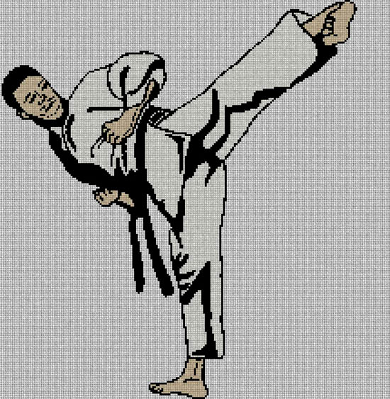
PATTERNS

Yellow Stripe (9th Kup) is now allowed in competitions. They are in with Yellow belt (8th Kup) and Green stripe (7th Kup). They are all in one division coded “YE” on the entry form.

JUNIORS CADETS
Up to & including 14 yrs old) 15 yrs up to & including 17 yrs)
Boys & Girls Separate Divisions Male & Female Separate Divisions.
Yellow Stripe. Yellow Belt/Green Stripe Yellow Stripe. Yellow Belt/Green Stripe
Together Green Belt & blue tag all together. Blue & red together.

Yellow Stripe | Chon Ji only
Yellow Belt | Chon Ji or Dan Gun
Green Belt | Do San or Won Hyo
Blue Belt | Yul Gok or Joong Gun
Red Belt | Toi Gye or Hwa Rang
Black Belt | Any pattern of grade (see list below)
Yellow Stripe | Chon Ji only
Yellow Belt | Chon Ji or Dan Gun
Green Belt | Do San or Won Hyo
Blue Belt | Yul Gok or Joong Gun
Red Belt | Toi Gye or Hwa Rang
Black Belt | Any pattern of grade (see list below)

COLOURED BELT MEN COLOURED BELT LADIES

Yellow Stripe | Chon Ji only
Yellow Belt | Chon Ji or Dan Gun
Green Belt | Do San or Won Hyo
Blue Belt | Yul Gok or Joong Gun
Red Belt | Toi Gye or Hwa Rang
Yellow Stripe | Chon Ji only
Yellow Belt | Chon Ji or Dan Gun
Green Belt | Do San or Won Hyo
Blue Belt | Yul Gok or Joong Gun
Red Belt | Toi Gye or Hwa Rang

BLACK BELT MEN BLACK BELT LADIES

1st Dans | Any pattern of Grade See List Below
2nd Dans & above | Any pattern of Grade See List Below
1st Dans | Any patterns of Grade. See List Below
2nd Dans & above | Any patterns of Grade. See list below
BLACK BELT PATTERNS LIST.

1st Dan | Choong Moo/Kwang Gae/Po-Eun/Ge-Baek
2nd Dan | Choong Jan/Ko-Dang/Eui-Am
3rd Dan | Choi Young/Yoo-Sin/Sam-Il
4th Dan | Tong-Il/Ul-Ji/Se-Jong
5th Dan | Yon-Ge/Moon-Moo/So San

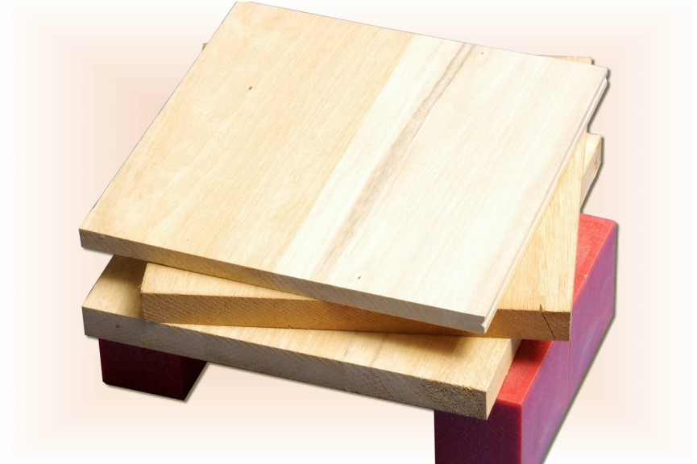
DESTRUCTION
MALE HAND: REVERSE KNIFE HAND STRIKE. MALE FOOT: 360 JUMPING BACK KICK
FEMALE HAND: ANY TECHNIQUE. FEMALE FOOT: ANY TECHNIQUE.

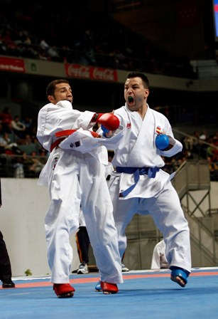
TEAM EVENTS: (TAG)

All teams will consist of 3 people; bouts will be 4 minutes in duration. Each time the bout is stopped you can change with a member of your team by tagging their glove. All 3 members must fight at some stage during the bout. All team matches will be point stop.

DIVISIONS:
MALE: 3 person teams. White/yellow/green together. No weights
3 person team. Blue/red together. No weights
3 person team. Black belts only. No weights.

FEMALE: 3 person team. White/yellow/green together. No weights.
3 person team. Blue/red together. No weights
3 person team. Black belts only. No weights.

JUNIORS 3 person team. White/yellow/green together. Pee wee
(Boys & girls separate) 3 person team. White/yellow/green together. Lightweight.
3 person team. White/yellow/green together. Middleweight.
3 person team. White/yellow/green together. Heavyweight.
3 person team. Blue/Red together. Pee wee
(Boys & girls separate) 3 person team. Blue Red together. Lightweight.
3 person team. Blue/Red together. Middleweight.
3 person team. Blue/Red together. Heavyweight.

3 person team. Black Belts Only. Pee. wee
(Boys & girls separate) 3 person team. Black Belts Only. Lightweight.
3 person team. Black Belts Only. Middleweight.
3 person team. Black Belts Only. Heavyweight.

THERE ARE NO DIVISIONS FOR EXECUTIVES OR CADETS IN THE TEAM EVENT. THEY CAN HOWEVER, COMPETE IN THE ADULT OR JUNIOR DIVISIONS.

