BRITISH LIBERATED TAEKWONDO SCHOOLS ALLIANCE

MEMBERSHIP APPLICATION FORM

PLEASE COMPLETE THIS APPLICATION FORM IN BLOCK CAPITALS
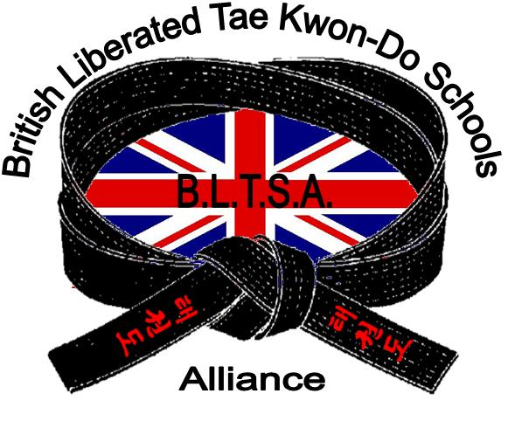

NEW APPLICATION
RENEWAL
RE-STARTING
LOST DETAILS

(Please hand in your licence book)

BLTSA SCHOOL……………………………………………….PREVIOUS TKD SCHOOL………..…………………………

STUDENT ID No…………………..LICENCE No……………………………..EXPIRY DATE…………………….………

GRADE No……………….KUP / DAN SENIOR / JUNIOR (under 16 years) MALE / FEMALE

DO YOU SUFFER FROM ANY OF THE FOLLOWING? Tick if Yes HEART DISORDER / ASTHMA / MIGRAINE /
EPILEPSY / DIABETES / NERVOUS DISORDER / HAEMOPHILIA / HAY FEVER / Any Others………………………

HAVE YOU ANY PHYSICAL INJURIES OR DISABILITIES…………………………………………………………………

HAVE YOU EVER BEEN CONVICTED OF A CRIME OF VIOLENCE? YES / NO

If YES please give details………………………………………………………………………………………………………..

DATE COMMENCED TRAINING……………………………….DATE OF LAST GRADING………………………………

FORENAMES……………………………………..SURNAME…………………………………………………………………

ADDRESS…………………………………………………………………………………………………………………………

………………………………………………………………………………………………………………………………………

………………………………………………………………………………..POSTCODE……………………………………...

TEL No…………………………………………………..EMAIL…………………………………………………………………

OCCUPATION…………………………………… DATE OF BIRTH………………………… (This MUST be completed)

HAVE YOU BEEN SHOWN YOUR INSURANCE DETAILS YES / NO

PLEASE TICK THE BOX IF YOU DO NOT WISH TO RECEIVE INFORMATION FROM THE BLTSA OR ASSOCIATED ORGANISATIONS

DECLARATION

I understand that there is an inherent risk of physical injury in the practice and learning of a contact sport such as Tae Kwon-Do. Whilst the BLTSA and Association schools and Instructors will take all reasonable steps to minimise the likelihood of an accident, the risk of physical injury cannot be eliminated.
There is a particular risk in the context of competitions and grading exercises which by their nature are likely to result in an individual approaching and potentially exceeding the limits of their skills and physical ability. The acceptance of an individual’s application to participate in a competition or to undertake a grading exercise does not constitute and should not be considered as constituting any form of confirmation or assurance by the BLTSA or any Association School or Instructor to the affect that the individual has the necessary skill or physical ability to safely complete such competition or grading exercise, it being the individual’s sole responsibility to judge such matters for themselves.
If an individual has any doubt whatsoever as to their ability to safely complete any exercise in the context of a competition, grading exercise or otherwise it is the responsibility of the individual to withdraw from the same.
The BLTSA, and Association schools and Instructors accept no liability for injuries sustained in the course of practicing and learning of Tae Kwon-Do save for injuries attributed to negligence of the BLTSA, and Association schools and Instructors. Insurance in respect of such risks is included in your annual membership. In signing this declaration I accept the above recited disclaimer of liability and also agree to abide by the rules of the BLTSA as amended from time to time should I be accepted as a member.

APPLICANT’S SIGNATURE………………………………………………………..….....DATE……………….……………..
(Parents’ if under 18 years)

INSTRUCTOR’S SIGNATURE……………………………………………………...........DATE…………….……………….

INSTRUCTOR’S NAME (BLOCK CAPITALS)………………………………………….GRADE……………..….………….

COST FOR NEW APPLICATIONS & RENEWALS BEFORE EXPIRY DATE £20.00
LATE RENEWALS (IF YOUR LICENCE HAS ALREADY EXPIRED) £25.00
(PLEASE MAKE ANY CHEQUES PAYABLE TO YOUR INSTRUCTOR / SCHOOL GROUP, NOT THE BLTSA)

